The Iris
JCL Newsletter Issue No. 2
Eagle Ridge Academy

Editor’s Note, LPotM
Interview w/ Hades
Q and A with JCL President Gillian Herbert
Ask Atticus

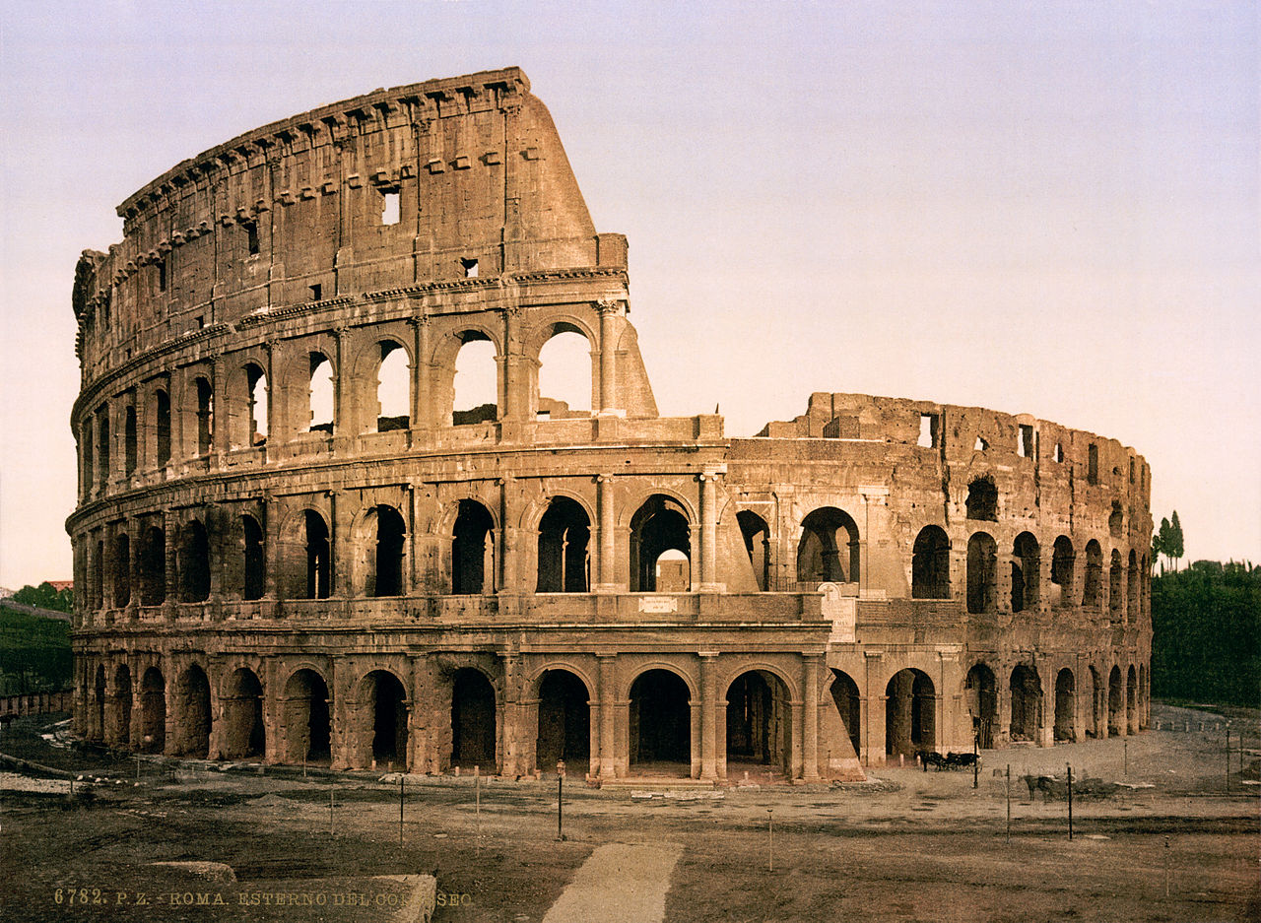
President: Gillian Herbert
First VP: Eden Edwards
Secretary: Sridhatri Guntipally
Parliamentarian: Dorie Bixby
Editor/Historian: Helena Holland
Second VP: Dexter Montague
MS President: Sudeeksha Nooka
MS VP: Amoligha Timma
Media Team: Elle Forsmark, Nick
Johnson, Samantha Erickson, Eden
Edwards

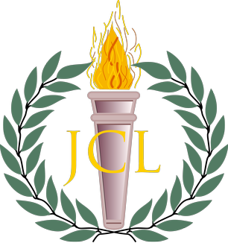
Salvete JCLers,

Congratulations on a great first semester! Thank you to all who participated in Ludi Romani on January 13th and represented Eagle Ridge Academy in the academic and athletic competitions. Now that we are in second semester, State Convention is approaching on March 9th and 10th, and we highly encourage all members to invite friends. Anyone, not just JCLers, can come to the convention, so please spread the word.
Members can view and submit photos of JCL events on the Minnesota website. If you have any photos from recent events or even events from previous years, please email them to hmholland1@gmail.com to be displayed on the website. In addition, anyone can send poems or short stories to this email to be featured in The Iris. If you are interested, please contribute.
A special thanks to the 2017-18 JCL officers for their diligence in making this year a success, and thank you to the Media Team for their collaboration in creating this newsletter.

Please enjoy,
- Helena Holland (Editor/Historian)

Latin Phrase of the Month:

“ Si hortum in bibliotheca
Habes, nihil deerit. ”
- Marcus Tullius Cicero

(translation can be found on the last page)

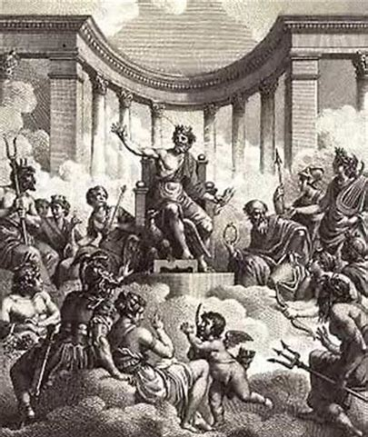
An Interview with Hades
By Samantha Erickson

Interviewer: So, Hades, how does it make you feel when everyone treats you like the bad guy? From what I've heard, you're a pretty cool guy.
Hades: You know, to be totally honest, it hurts. I try to be the best I can be in the situation I've been stuck with.
Interviewer: I understand. By all logic, you should be in Zeus’ place. You're the eldest, but you always seem to draw the short end of the stick. Eaten by Cronus first, thrown up by him first, stuck in the Underground, and unrightfully hated by everyone.
Hades: It sucks. I've had some tough times, and I don't want people thinking I'm perfect. I kidnapped my wife, for instance. Most people don't consider that a good thing. I am, however, faithful to her, unlike a certain other god up on Olympus.
Interviewer: Yeah, for the most part you mind your own business, whereas all the other gods are out there are interfering with human relations and meddling in things that shouldn't interest them. Just know that there are people looking out for you, Hades. If you ever need help, someone is there.
Hades: Thank you. And thank you for having me here.
Interviewer: You're welcome. But remember, that's just an interview...a god interview. Thanks for reading.

Q and A with JCL President
Gillian Herbert

What is your favorite thing about JCL?
- My favorite thing about JCL is the community-aspect of JCL! The fact that so many people from all over the country get together to nerd out about the classics is incredible! It is also amazing to get to be able to meet so many new friends in JCL chapters across the chapter and within our own JCL chapter.
Who is your least favorite hero from Greek mythology? Why?
- My least favorite hero from Greek mythology is Agamemnon. Agamemnon was a terrible leader who contributed very little in the Trojan War and was only concerned with his own well-being; however, my main reason for disliking him is the fact that we spent a whole week talking about whether or not Agamemnon was a good leader in a Humanities discussion, and by the end of it I had been asked to “provide text evidence” so many times that I was just over him.
Which god or goddess would you say you are most like? Why?
- I would say that I am most like Athena, because I value education and hard work, and am also very competitive.
What aspect of Roman culture would you like to lift into the modern era?
- I would love to bring certain elements of Roman houses to the modern era. I would especially want to have a peristylium, or an open courtyard within the house filled with statues, small trees, and plants.
Any advice for this year's JCLers?
- I would advise this year’s JCL-ers to try and make friends with new people that they would not normally talk to. Believe me, I know how scary it can seem to talk to people in other grades or groups, but you will thank me for it later. I have made many great friends this way, and I am sure you all will to!

Ask Atticus

What advice do you have for someone who just failed all of their finals?
- You failed all of your finals? I must say, that’s actually quite impressive given that at least one of your classes had to have been one of those “filler classes” we all so love and dread.
How can I actually pass my finals this semester? Is it even possible?
- Funnily enough, studying will just make you a lot more stressed before finals, so instead try… paying attention during class and taking notes?
I hate my new schedule!!!
- (that’s not a question but…) You can change your schedule by talking with Ms. Klute, or by sucking it up and adapting to change.
Who even are you?
- Who are you? You’re a nameless and annoyingly sarcastic disembodied entity, just like me, except my name is Atticus.
Why is the sky blue?
- We live in the eye of a blue eyed giant named Macumber, and when he sleeps the sky turns black.
When will the world end?
- When Macumber dies, obviously.
Where are you from?
- Either Maycomb, Alabama or an immortal from 1st century Athens, Greece.

Want to submit questions for Atticus to answer? Send us an email!--hmholland1@gmail.com or
nickallanj3@gmail.com

Latin Phrase Translation

“ If you have a garden and a library,
you have everything you need. ”

