The Iris
JCL Newsletter Issue No. 1
Eagle Ridge Academy
Editor’s Note
On This Day in History
Q and A with 2nd VP Dexter Montague
Ask Atticus
Book Recommendations
Pompeian Discovery
November Zodiacs
Endnotes
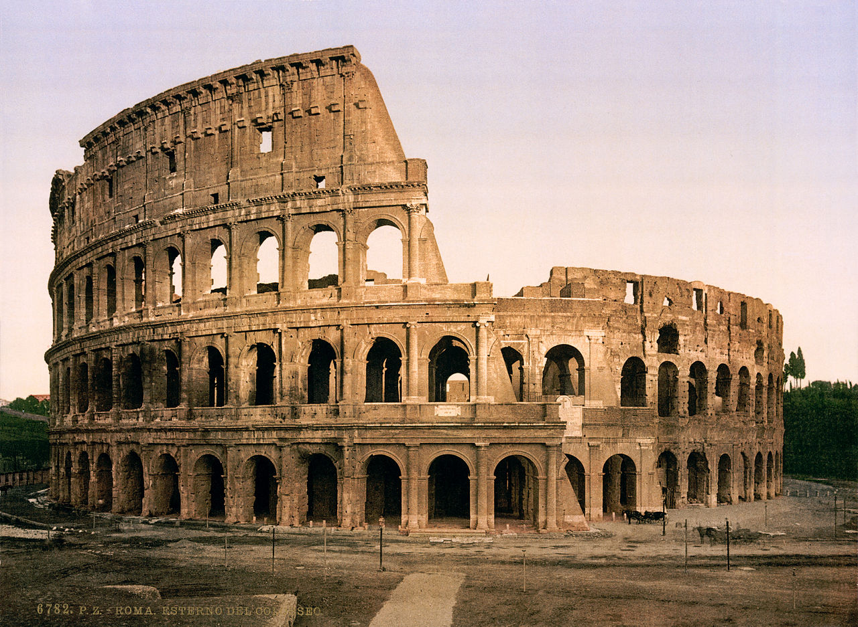
President: Gillian Herbert
First VP: Eden Edwards
Secretary: Sridhatri Guntipally
Parliamentarian: Dorie Bixby
Editor/Historian: Helena Holland
Second VP: Dexter Montague
MS President: Sudeeksha Nooka
MS VP: Amoligha Timma
Media Team: Elle Forsmark, Nick Johnson, Samantha Erickson, Eden Edwards

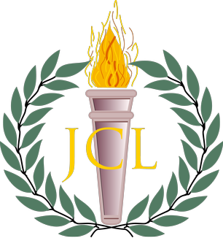

Welcome to the first issue of The Iris for the 2017-18 school year. This year of JCL has been off to an excellent start thanks to the continual energy and enthusiasm of our members. Thank you to all who came to our first event, the Ben-Hur movie night on November 2nd. It was a successful kick-off for the rest of the year. An event calendar is now available on the Minnesota JCL website, so please use this resource to view important dates in the upcoming months. JCL is planning a babysitting fundraiser on December 9th from 1-5 pm to give parents the opportunity to get ready for the holidays. Any JCL or NHS member is eligible to volunteer. Please let Mrs. Bergeron or the officers know if you are interested. While it is over three months away, the JCL State Convention will be on March 9th and 10th this year. State Convention is a highlight of JCL, so please mark this date in your calendars. We look forward to seeing your engagement and contributions.
A special thanks to the 2017-18 JCL officers for their diligence in making this year a success, and thank you to the Media Team for their collaboration in creating this newsletter.
Please enjoy,
Helena Holland (Editor/Historian)

On This Day in History
- November 4-17: The Plebeian Games
- November 8: Cicero’s First Speech Against Catiline
- November 16: Birthday of Emperor Tiberius

The lofty pine is oftenest shaken by the winds; High towers fall with a heavier crash; And the lightning strikes the highest mountain.
- Horace

The Plebeian Games
Held from the 14th to 17th of November, the Ludi Plebeii was an ancient Roman religious festival dedicated to the god Jupiter. It was originally held in the Circus Flaminius, named after the festival’s founder, but the setting was later moved to the Circus Maximus. Presented by the Roman aediles, the purpose of the Ludi Plebeii was to celebrate the political freedom of the commons. The first nine days of the festival were devoted to theatrical performances. In fact, it was during the Plebeian Games of 200 BC that the famous writer Plautus first presented his comedy Stichus. In the remaining days of the festival, the Romans enjoyed a feast of Jupiter, cavalry parades, circus games, wrestling, and chariot racing.

Latin Phrases for You to Know:
Sit vis nobiscum- May the force be with you.
Calvo turpuis est nihil comato- Nothing is uglier than a bald man with hair.
Fac ut vivas- Get a life.
Manus complexibus aufer- Get your hands off me!
Stultus est sicut stultus facit- Stupid is as stupid does.
Q and A with 2nd VP Dexter Montague
Which figure from Greek mythology would you say you are most like?
I think I am most like Pan and King Midas. The Pan side of me is obvious. I can be crazy and loud, not to mention I have this haunting scream and a wild night life (mostly sleep). My Midas side comes out less frequently, but when it does, I don't think ahead and only think of myself and my opinion. Feel free to give me a kick in the shins when I do this before I turn someone to gold!
What is your favorite thing about JCL? What is something you want to improve?
I love JCL because of the opportunities! It doesn't take much to have fun in this club, and any commitment pays off. What I don't like about JCL is that we aren't as much about charity, something I definitely hope to improve this year.
If you were forced to go on a date with any character from Homer's Iliad and Odyssey, who would it be? Why?
This one is tough. Out of all the chicks in these Homeric epics, few are unmarried... and the unmarried ones tend to be unsavory. I would choose Briseis, as she is relatively unimportant, unmarried, and is incredibly beautiful.
Who is your least favorite Greek god or goddess?
I absolutely abhor Hera. She's sorta the Oscar the Grouch of the Olympians.
Do you have any advice for this year's JCLers?
I encourage all JCLers to include everyone, and have fun. You might be tired or hungry or depressed, but that's no excuse to exclude others from the JCL experience. My final piece of advice? Obey your devilishly handsome 2nd VP unswervingly! ;)

Ask Atticus
Dear Atticus…
I caught my friend cheating on his Latin test… what should I do?
They’re the ones who will fail the class in the long run, if not by getting caught then by not participating in class and getting docked points there. If it bothers you, talk to them, or even talk to the teacher if you want to lose your friendship.

My sister’s birthday is on February 29th, how should we celebrate her birthday this year?
Just celebrate it on February 30th.

How do I get over my fear of failure?
You can’t. You never will be able to. Give up trying.

Sparknotes is down, and I didn’t do my reading for Humanities!
When in doubt, discuss the book like you know what you’re talking about until the teacher asks to see your notes, and you desperately “scramble” to find the “notes” that you never took.

Book Recommendations:
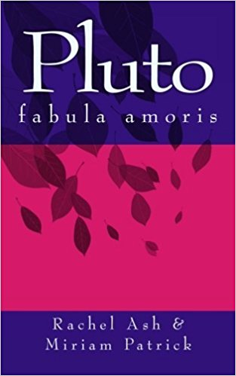
This is a Latin reader for students in their first to second year of study of Latin. The book runs approximately 1,050 words with a very limited vocabulary of 148 words (not counting different forms). This second edition contains updates to the text and format.

4/5
Amazon Paperback: $6.00

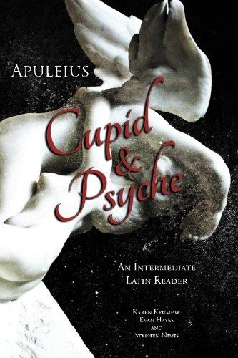

The aim of this book is to make the story of "Cupid and Psyche" from Apuleius' The Golden Ass accessible to intermediate students of Ancient Latin. The running vocabulary and grammatical commentary are meant to provide everything necessary to read each page so that readers can progress through the text, improving their knowledge of Latin while enjoying one of the most delightful stories from antiquity.

5/5
Amazon Paperback: $11.96

Ancient Romans in Pompeii Had ‘Perfect Teeth’
Source: Marissa Fessenden, Smithsonian.com

Mt. Vesuvius erupted in 79 AD, covering the town of Pompeii in pumice and ash. The eruption preserved the city and its culture, but there are still many questions surrounding the people who lived there. Scientists have conducted a new examination of the plaster casts created by archaeologists in the 1800s.
According to the CAT scans of thirty body casts, most of the eruption victims died of head injuries. The analysis also revealed that Pompeians had nearly perfect teeth. A low-sugar diet, fruits and vegetables, and the fluorine present in the town’s water source gave them impeccable dental records. The study of teeth could reveal much about life in Pompeii. Researchers plan to scan 56 additional body casts, so more discoveries are sure to be on their way.

For more information, visit smithsonianmag.com.

Zodiac Signs for November

Aries (March 21-April 19)
November is your month to relearn fun! Find your way back to relaxation. You’ve really been working hard, and you deserve it! Slow down and live a little this Thanksgiving holiday! Live to live right now.

Taurus (April 20- May 20)
Taurus, be an adventurer this month. Take some risks, try something new! This month brings balance into your present and future. For some, you may find a new romantic interest. For others, relationships will be strengthened. Put some energy into your endeavors!

Gemini (May 21- June 20)
You will be prosperous, Gemini! Give some extra attention to your relationships this month, especially ones of romantic nature. If you’re single, keep an open mind and open heart. You never know what might be coming around the corner!

Cancer (June 21- July 22)
You are mentally clear and strong this month, Cancer. Use this to make big decisions about any action you’ve been deciphering. Others will come to you for advice, but don’t forget to leave some time for yourself, Cancer. Let go and live life!

Leo (July 23- August 22)
Make peace with yourself this month, Leo. Don’t try to rush everything now. The people in your life now will influence your future. If it’s meant to happen, it’ll happen. Don’t overwork yourself and try to truly relax this month. Refocus a little.

Virgo (August 23- September 22)
Your heart aches this month. Let yourself heal and take some time to yourself. Once you start to let yourself heal, you will start to enjoy life so much more. But this month is also for celebrating! Enjoy the positive moments and keep an open mind this month, Virgo.

Libra (September 23- October 22)
Libra, this is a beautiful month for you! You have learned so much about yourself and life in the last year. Working feels amazing, respect and adoration from others is spilling onto you and it’s well deserved! One of the important lessons for you is presenting itself this month. Keep an eye out!

Scorpio (October 23- November 21)
It’s your birthday month! Keep reminding yourself of your brightness this month. Life is good, but you’re blocking it out. Take a step back and relish it. Don’t criticise yourself too much. Remind yourself how great you are!

Sagittarius (November 22- December 19)
Times may feel hard for you this month, but, family is filling you with love. Allow yourself to lean on others at this time. This isn’t a time to go through life alone. Remember that what doesn’t kill you makes you stronger. Your friends and family will always support you. Let them raise you up!

Capricorn (December 20- January 19)
You will feel the success this month. After some rough times, your confidence is swelling. Don’t stress if you haven’t got everything you’ve wanted, it’ll come. Accept this month as improvement and take criticism from others, but don’t be too hard on yourself. It’s all coming together.

Aquarius (January 20- February 18)
The struggle is real right now for you, Aquarius. Work and school is stressing you out, but don’t feel overwhelmed. Take a step back and put that emotion and passion into your relationship or into opening your heart to others. You are great at showing your passion, but practice throwing it at something else.

Pisces (February 19- March 20)
Feel your way through the ups and downs this month, Pisces. Letting go of old emotional problems will help you experience this transformation. You were born to be one who feels more than most, and now is a time where you are being prepped to feel great without having to question things.

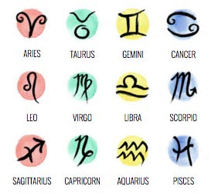
Non-Convention Contests:
In addition to competitions at local and state conferences as well as the annual NJCL Convention, JCL members can participate in a variety of activities including:
Club of The Month - Every club does creative and special events to encourage the study of the Classics and to help its community. Write about your club's events and submit it for the Club of the Month award!
Community Service Contest - This contest awards local chapters on the basis of community service. Please contact the Second Vice-President for information on this contest.
Creative Writing Contest - This contest allows members to demonstrate their writing talents via an essay of about 1000 words on a classically related theme or situation. Deadline for this contest is usually near the end of February.
Membership Contest - This contest recognizes those states and provinces that have made significant strides in the academic year to increase their membership in terms of number of chapters and total members.
Programs and Activities Contest - This contest will be a way to foster ideas and spread the Classics between local JCL Chapters. The Contest gives the opportunity for local clubs to share what they are doing.
Promotional Video Contest - This contest awards JCLers for videos promoting Latin, Greek, JCL, and related topics. The deadline is May 31.
Please let the officers know if you are planning on participating in the creative writing contest, as well as any ideas you may have for contests involving the whole group.
For more information, visit njcl.org.
___________________________________________________________________________________________________________
Upcoming Events
- December 4: National Etymology Exam
- December 9, 1-5 pm: JCL Babysitting service, Parents’ Day Out
- March 9-10: JCL State Convention

Follow JCL on Social Media:
Instagram: mnjcl
Website: minnesotajcl.weebly.com

Credits:
Media Team: Samantha Erickson, Nick Johnson, Eden Edwards, Elle Forsmark
Editor/Historian: Helena Holland

